Tea Extracts – Black & Green Tea Export Range by The Export Express
Premium Natural Extracts for Global Beverage, Nutraceutical, and Cosmetic Industries
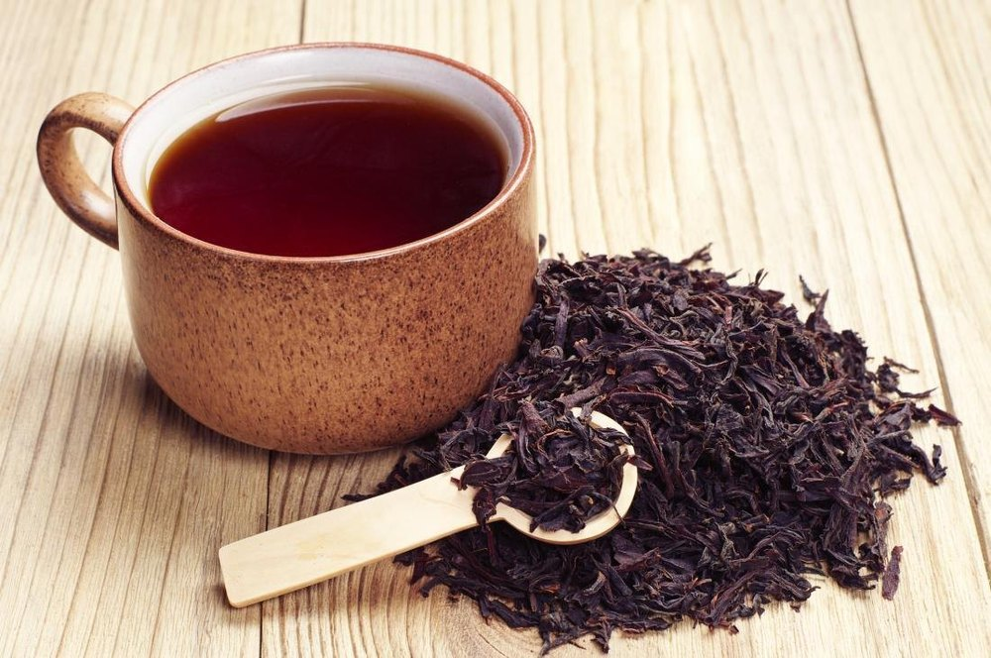

Introduction
Tea is more than a beverage — it is an ancient elixir, cherished worldwide for its flavor, aroma, and health-promoting properties. At The Export Express, we bring the finest Black and Green Tea Extracts from India’s renowned tea-growing regions, processed using advanced extraction and drying technologies to preserve natural antioxidants, polyphenols, and catechins.
Our Tea Extract Range is designed for international manufacturers, formulators, and wellness brands seeking high-quality soluble extracts for beverages, supplements, functional foods, cosmetics, and herbal preparations.

🌿 What Are Tea Extracts?
Tea Extracts are concentrated powders or liquids derived from tea leaves (Camellia sinensis). Using water or ethanol-based extraction, the bioactive compounds are separated, standardized, and dried into a soluble form.
Two main variants:
- Black Tea Extract (Oxidized, Rich & Malty)
- Green Tea Extract (Unoxidized, Light & Antioxidant-Rich)
Each extract has distinct polyphenol, caffeine, and flavor characteristics, making them ideal for diverse industries.

🖤 Black Tea Extract – Bold, Aromatic & Functional
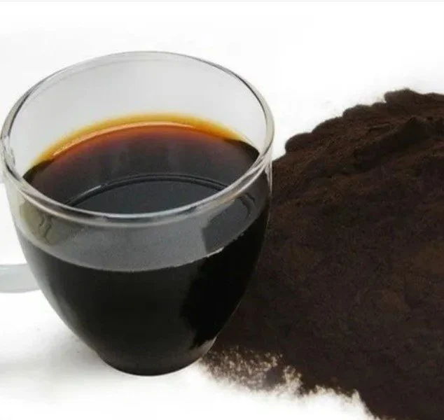
Caption: “Black Tea Extract – Soluble Natural Powder for RTD Teas”

Product Overview
- Form: Powder
- Packaging Size: 1–50 kg (HDPE Drum / Plastic Bottle)
- Shelf Life: 24–36 Months
- Origin: Made in India
- Availability: In Stock
Black Tea Extract is a fully oxidized tea extract rich in theaflavins and caffeine. It offers a strong color, robust taste, and numerous functional benefits.

Key Features
- Cold Water Soluble: Suitable for RTD beverages and instant mixes
- Rich in Polyphenols: 3%–10%, supporting antioxidant activity
- Caffeine Range: 0.5%–4% for natural energy enhancement
- Applications: Beverages, supplements, cosmetics, and flavor enhancers

Benefits & Applications
Application | Function
RTD Teas & Instant Drinks | Adds rich flavor and color
Nutraceuticals & Supplements | Natural source of caffeine & antioxidants
Bakery & Confectionery | Flavor enhancement & color stability
Cosmetics | Antioxidant, anti-aging, and skin protection benefits
Functional Foods | Natural stimulant and flavor base

Technical Data
Parameter | Specification
Form | Powder
Color | Deep Brown to Black
Solubility | Water Soluble
Polyphenols | 3–10%
Caffeine | 0.5–4%
Shelf Life | 36 Months
Packaging | HDPE Drum / Plastic Bottle
Country of Origin | India

Green Tea Extract – Rich in Polyphenols & Catechins
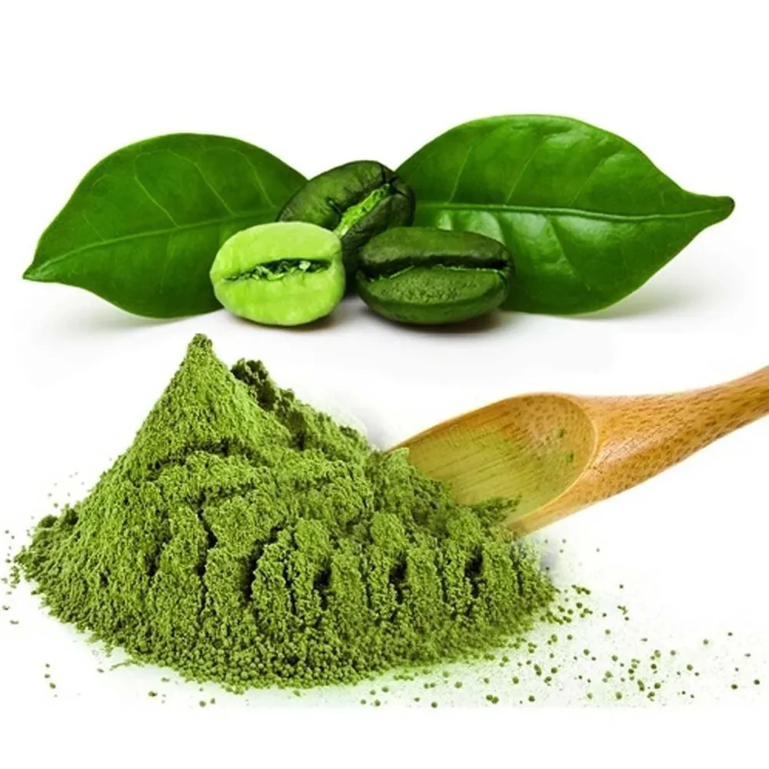
Caption: “Fine Green Tea Extract Powder – Rich in Catechins & Antioxidants”

Product Overview
- Form: Powder
- Packaging Size: 25 kg Drum / 1 kg Loose Pack
- Color: Green to Greenish Brown
- Shelf Life: 2–3 Years
- Active Assay: Polyphenols 50%–90% (Standardized)
- Availability: In Stock

Key Features
- Standardized Extracts: Available in 50% & 90% polyphenol concentrations
- High EGCG Content: Potent antioxidant supporting wellness and longevity
- Natural Source of Caffeine & L-theanine: Promotes mental alertness and relaxation
- Dried Powder Form: Ideal for supplements, beverages, and herbal capsules

Health Benefits
- Supports Weight Management: Promotes thermogenesis and fat oxidation
- Boosts Heart Health: Aids cholesterol balance and blood pressure regulation
- Enhances Brain Function: L-theanine and caffeine combination improves focus
- Detoxifies the Liver: Supports liver enzyme function and reduces oxidative stress
- Promotes Glowing Skin: Antioxidants fight free radicals and premature aging

Safety & Precautions
- Contains natural caffeine; moderate consumption recommended.
- Avoid excessive intake for individuals with liver or heart conditions.
- Consult a healthcare provider before adding to dietary supplements.

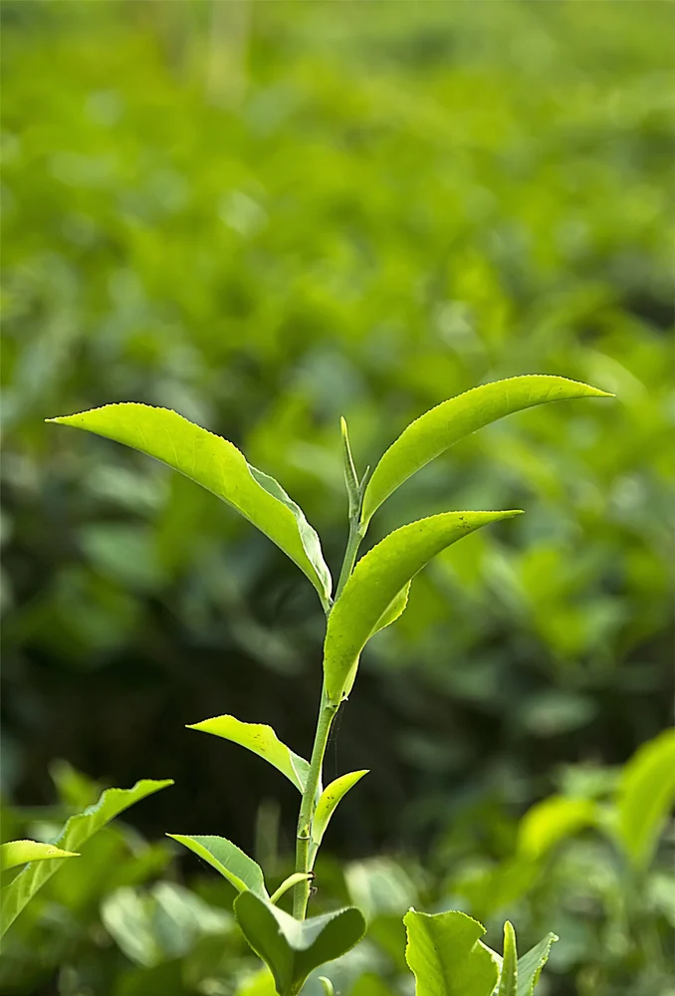

🧪 Green Tea Extract – Technical Specifications
Parameter | Value
Botanical Name | Camellia sinensis
Active Ingredient | Polyphenols (EGCG, Catechins)
Assay | 50%–90% by HPLC
Appearance | Fine greenish-brown powder
Odor/Taste | Characteristic tea aroma
Moisture | ≤ 5%
Bulk Density | 45–55 g/100 ml
Heavy Metals | NMT 20 ppm
Microbial Load | NMT 5,000 cfu/g
Packaging | HDPE Drum / Polybag
Shelf Life | 3 Years

☕ The Science Behind Extraction
Tea extracts are obtained through controlled water extraction at optimized temperatures. The liquid tea concentrate is then filtered, concentrated, and spray-dried into a free-flowing powder.
This process preserves vital bioactives like:
- Catechins (EGCG, EGC, ECG, EC)
- Caffeine
- Theaflavins & Thearubigins
The result is a highly soluble, shelf-stable extract that retains flavor and potency across applications.

🌍 Applications Across Industries

1. Beverage Industry
- Ready-to-Drink Teas (Cold or Hot)
- Instant Tea Premixes
- Energy Drinks and Kombucha

2. Food Industry
- Bakery fillings and glazes
- Ice creams, chocolates, and confectionery flavoring

3. Nutraceutical & Dietary Supplements
- Capsules and tablets
- Functional protein powders and detox blends

4. Cosmetics & Skincare
- Anti-aging serums and creams
- Natural antioxidant-infused cleansers and toners

5. Pharmaceuticals
- Formulations supporting weight management and digestion

📦 Packaging & Export Options
- Standard Packs: 1 kg, 5 kg, 25 kg, 50 kg
- Bulk Supply: HDPE drums with double polybag inner lining
- Private Labeling: Available upon request
- Custom Grades: Tailored for beverage, supplement, or cosmetic applications
Shelf Life: 2–3 years under cool, dry, airtight storage.
Origin: India (ISO, GMP, and FSSAI Certified Facilities)

🧭 Why Choose The Export Express for Tea Extracts
- High Purity Assurance: Standardized extracts with consistent potency
- Wide Range: Green and Black Tea extracts for varied applications
- Certified Quality: GMP, FSSAI, ISO-certified manufacturing partners
- Global Export Expertise: Hassle-free logistics and documentation support
- Private Label & OEM Manufacturing: Custom formulation and branding options

🌿 Sustainability & Ethical Sourcing
Our extracts are sourced from sustainably cultivated tea gardens across Assam, Nilgiris, and Darjeeling. We prioritize environmentally friendly extraction methods that conserve water, minimize waste, and ensure fair trade practices with local farmers.

📈 Global Market Outlook
With rising global demand for functional beverages, herbal supplements, and clean-label cosmetics, Indian tea extracts are emerging as key export commodities.
- Top Import Regions: USA, UAE, Germany, UK, and Japan
- Major Applications: Nutraceuticals, F&B, Skincare, and Wellness Formulations
- Export Advantage: Competitive pricing and strong quality compliance from India

🏁 Conclusion
At The Export Express, we combine tradition and technology to deliver the finest Black and Green Tea Extracts from India. Our extracts are crafted for taste, wellness, and innovation, catering to clients across beverage, nutraceutical, and personal care industries worldwide.
Whether you’re sourcing polyphenol-rich green tea extract for supplements or flavorful black tea extract for RTD drinks, we ensure premium quality, consistency, and purity in every shipment.
Explore our full range today — The Export Express, your trusted partner in herbal and botanical exports.

Keywords:
Tea Extract Export India | Black Tea Extract Supplier | Green Tea Extract Polyphenols | Tea Powder Exporter | Herbal Extract Manufacturer India | Natural Caffeine Extracts | The Export Express Tea Exports

